**<jts>**

**Data Specification**

Version <>

# Revision History

|  |  |  |  |
| --- | --- | --- | --- |
| Date | Version | Description | Author |
| <MM/DD/YYYY> | <version> | <description> | <author> |
|  |  |  |  |
|  |  |  |  |

# Table of Contents

Revision History 2

Table of Contents 3

Introduction 4

Purpose 4

Scope 4

Definition, Acronyms and Abbreviations 4

References 4

Database Design 4

Data Dictionary 4

Appendices 4

# Introduction

<Introduction of this Data Specification. What will be covered in this document? What is the aim of this document? What are the main focuses? >

## Purpose

<Purpose of this document. Do you write this document to describe the current database? Do you write this document as a guide to develop a new database? Do you expect the end user will gain a better understanding of the data structure by reading this document? Do others like system designer and developer to gain understanding of the data structure by reading this document?>

## Scope

<Scope of this document. What parties or systems will be mentioned or focused? Will you talk about the stakeholders, the existing process and computer system in-use?>

## Definition, Acronyms and Abbreviations

<Collection of terms to be used in this document, with their definition. For example, you may want to describe the word ‘legacy’ that appears in your entity description>

|  |  |
| --- | --- |
| Term | Definition |
|  |  |

## References

<A list of reference material used by this document.>

# Database Design

## Entity Relationship Diagram1

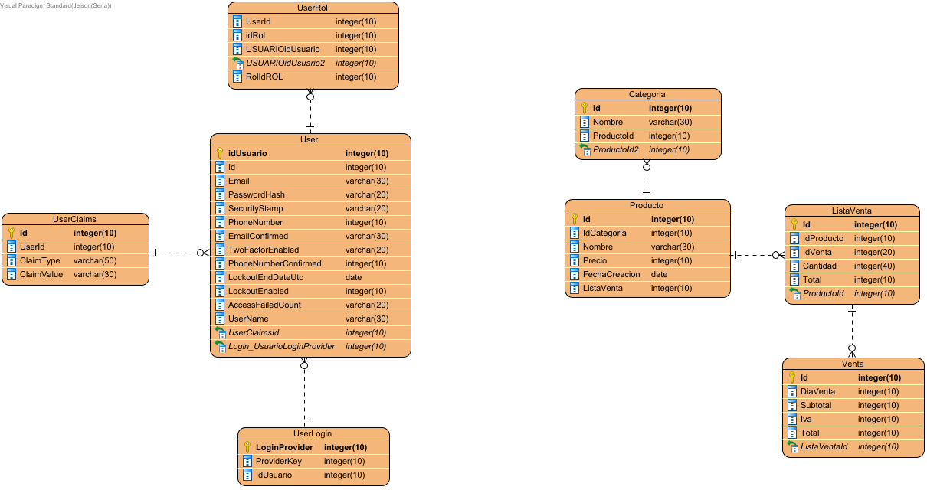

# Data Dictionary

## Data Dictionary

|  |  |  |  |  |  |  |  |  |  |
| --- | --- | --- | --- | --- | --- | --- | --- | --- | --- |
| Entity Name | Entity Description | |  |  |  |  |  |  |  | | --- | --- | --- | --- | --- | --- | --- | | Column Name | Column Description | Data Type | Length | Primary Key | Nullable | Unique | |
| Categoria |  | | Id |  | integer | 10 | true | false | false | | --- | --- | --- | --- | --- | --- | --- | | Nombre |  | varchar | 30 | false | false | false | | ProductoId |  | integer | 10 | false | false | false | | ProductoId2 |  | integer | 10 | false | false | false | |
| ListaVenta |  | | Cantidad |  | integer | 40 | false | false | false | | --- | --- | --- | --- | --- | --- | --- | | Id |  | integer | 10 | true | false | false | | IdProducto |  | integer | 10 | false | false | false | | IdVenta |  | integer | 20 | false | false | false | | ProductoId |  | integer | 10 | false | false | false | | Total |  | integer | 10 | false | false | false | |
| Producto |  | | FechaCreacion |  | date | 0 | false | false | false | | --- | --- | --- | --- | --- | --- | --- | | Id |  | integer | 10 | true | false | false | | IdCategoria |  | integer | 10 | false | false | false | | ListaVenta |  | integer | 10 | false | false | false | | Nombre |  | varchar | 30 | false | false | false | | Precio |  | integer | 10 | false | false | false | |
| User |  | | AccessFailedCount |  | varchar | 20 | false | false | false | | --- | --- | --- | --- | --- | --- | --- | | Email |  | varchar | 30 | false | false | false | | EmailConfirmed |  | varchar | 30 | false | false | false | | Id |  | integer | 10 | false | false | false | | idUsuario |  | integer | 10 | true | false | false | | LockoutEnabled |  | integer | 10 | false | false | false | | LockoutEndDateUtc |  | date | 0 | false | false | false | | Login_UsuarioLoginProvider |  | integer | 10 | false | false | false | | PasswordHash |  | varchar | 20 | false | false | false | | PhoneNumber |  | integer | 10 | false | false | false | | PhoneNumberConfirmed |  | integer | 10 | false | false | false | | SecurityStamp |  | varchar | 20 | false | false | false | | TwoFactorEnabled |  | varchar | 20 | false | false | false | | UserClaimsId |  | integer | 10 | false | false | false | | UserName |  | varchar | 30 | false | false | false | |
| UserClaims |  | | ClaimType |  | varchar | 50 | false | false | false | | --- | --- | --- | --- | --- | --- | --- | | ClaimValue |  | varchar | 30 | false | false | false | | Id |  | integer | 10 | true | false | false | | UserId |  | integer | 10 | false | false | false | |
| UserLogin |  | | IdUsuario |  | integer | 10 | false | false | false | | --- | --- | --- | --- | --- | --- | --- | | LoginProvider |  | integer | 10 | true | false | false | | ProviderKey |  | integer | 10 | false | false | false | |
| UserRol |  | | idRol |  | integer | 10 | false | false | false | | --- | --- | --- | --- | --- | --- | --- | | RolIdROL |  | integer | 10 | false | false | false | | UserId |  | integer | 10 | false | false | false | | USUARIOidUsuario |  | integer | 10 | false | false | false | | USUARIOidUsuario2 |  | integer | 10 | false | false | false | |
| Venta |  | | DiaVenta |  | integer | 10 | false | false | false | | --- | --- | --- | --- | --- | --- | --- | | Id |  | integer | 10 | true | false | false | | Iva |  | integer | 10 | false | false | false | | ListaVentaId |  | integer | 10 | false | false | false | | Subtotal |  | integer | 10 | false | false | false | | Total |  | integer | 10 | false | false | false | |

# Appendices